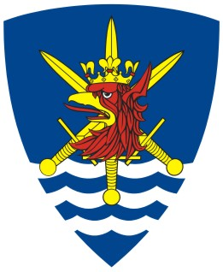

HEADQUARTERS

MULTINATIONAL CORPS NORTHEAST

Public Affairs Office

W. Łukasińskiego 33, 71-215 Szczecin, Poland
Tel: +48 (91) 44 45 955 Fax: +48 (91) 44 45 957

E-mail: contact@hqmncne.mil.pl
www.mncne.pl

The Corps’ 10th Anniversary

The year 2009 marks the 10th Anniversary of inaugurating Multinational Corps Northeast in Szczecin. On this occasion, MNC NE Commander Lieutenant General Zdzisław Goral has a great pleasure to invite all inhabitants of Szczecin, media representatives, the Corps’ enthusiasts, military fans and anyone interested for the celebrations taking place at “Wały Chrobrego”, Szczecin, on 19th and 20th September 2009. It will be an excellent opportunity to learn more about the Corps, meet representatives of all 11 Corps’ nations as well as to try military cuisine and simply have a good time.

The programme of celebrations 19th and 20th September 2009:

Saturday, 19th September 2009, the Harbour Area:
14:00 - 15:30 - the official part of celebrations including military parade of military bands from Denmark, Germany and Poland accompanied by guards of honour;
16:00 - 17:00 - concert of Polish Navy Military Band from Świnoujście;
19:00 - 20:30 - concert of folk band “Greenwood”;
20:30 - 22:00 - concert of shanty-rock band “Stary Szmugler”;
22:00 - fireworks.

Additional attractions:
- MNC NE promotion tent - a photographic studio, exhibitions, multimedia presentations, “Meet my Army” programme etc.;
- Warships from Denmark, Germany and Poland open to the public;
- Display of heavy equipment (tanks, artillery, armoured vehicles etc.) from Germany and Poland;
- Display of equipment of Polish mechanised infantry section
- Field kitchen and field bakery;
- Karate competition by Szczecin Garrison Club;
- Concert of Royal Danish Lifeguard Music Corps next to the Cathedral, at 20:00.

Sunday, 20th September 2009, the Harbour Area:
15:00 - 16:00 - concert of Szczecin Garrison Military Band;
16:00 - 17:00 - concert of band “Dair” playing Celtic music.

Additional attractions starting from 10:00:
- MNC NE promotion tent - a photographic studio, exhibitions, multimedia presentations, etc.;
- Warships from Denmark, Germany and Poland open to the public;
- Display of heavy equipment (tanks, artillery, armoured vehicles etc.) from Germany and Poland;
- Display of equipment of Polish mechanised infantry section;
- MNC NE exhibition at the National Museum in Wały Chrobrego 3, open till 16:00, free entrance.

